**Project Report**

**Topic: Cinema Ticket Booking System**

**Group Members:**

* **Murtaza Najmi 1912238**
* **Bilal Qader 1912391**
* **Ashesh Kumar Rejhra 1912219**
* **Avinash Rejhra 1912221**

**Introduction for our project:** I have decided to do comprehensive UML model of the cinema booking System.

In my project I am working with Cinema booking system that how does cinema booking system works by working on customerdetails, paymentdetails, theatre, seat, row, movies, and booking.

In cinema booking system when we open there is we get different movies in which (movies types are available, drama movies, Action) and we can book ticket.

There is an option to select movie, select theatre, select row, seat, book ticket, payment method.

* In select movie have to provide movies name.
* In select theatre we can select theatre.
* In display shows by name we can see details of owner flat and information by just searching it with name.
* We can create seats and rows.
* In book ticket we can book ticket.
* In exit we can exit.

**Main Class:**

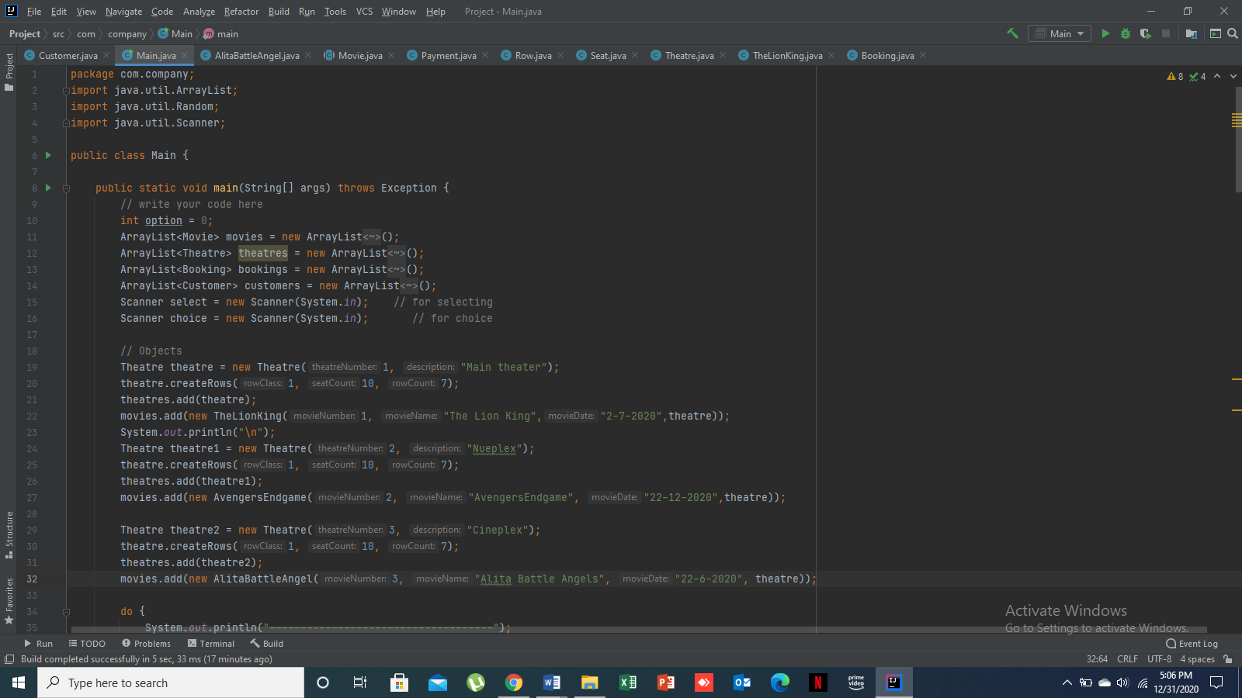

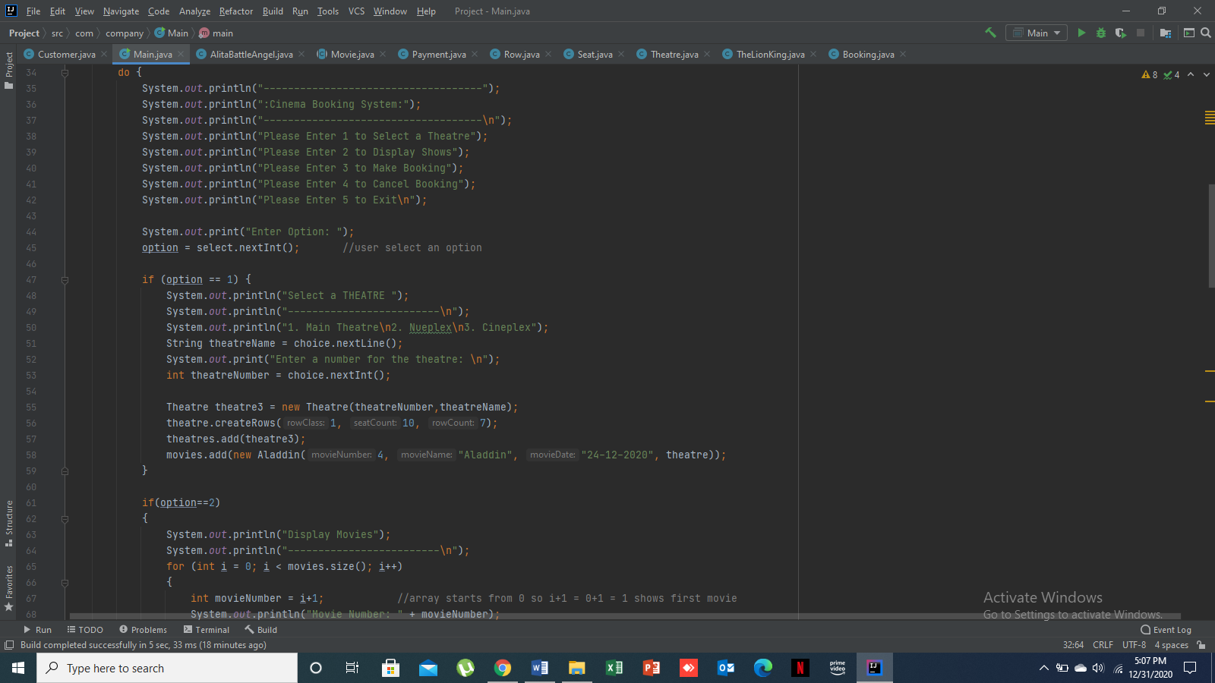

**Movie Class:**

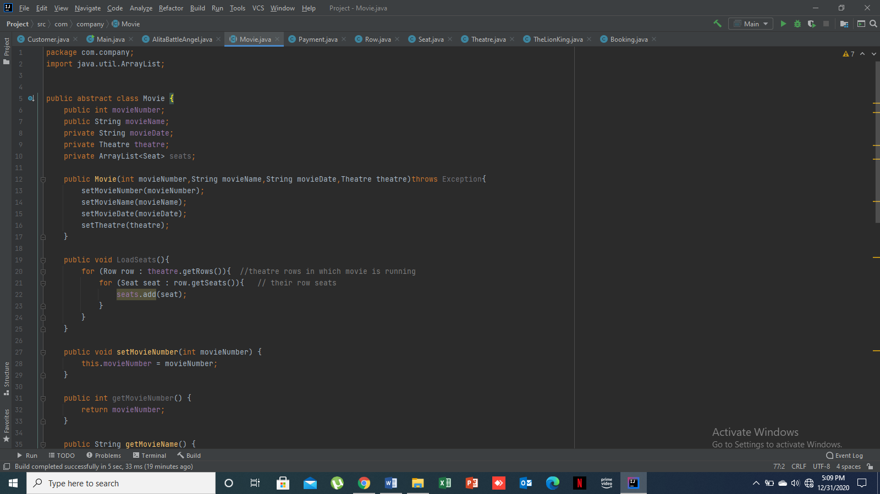

**Booking Class:**

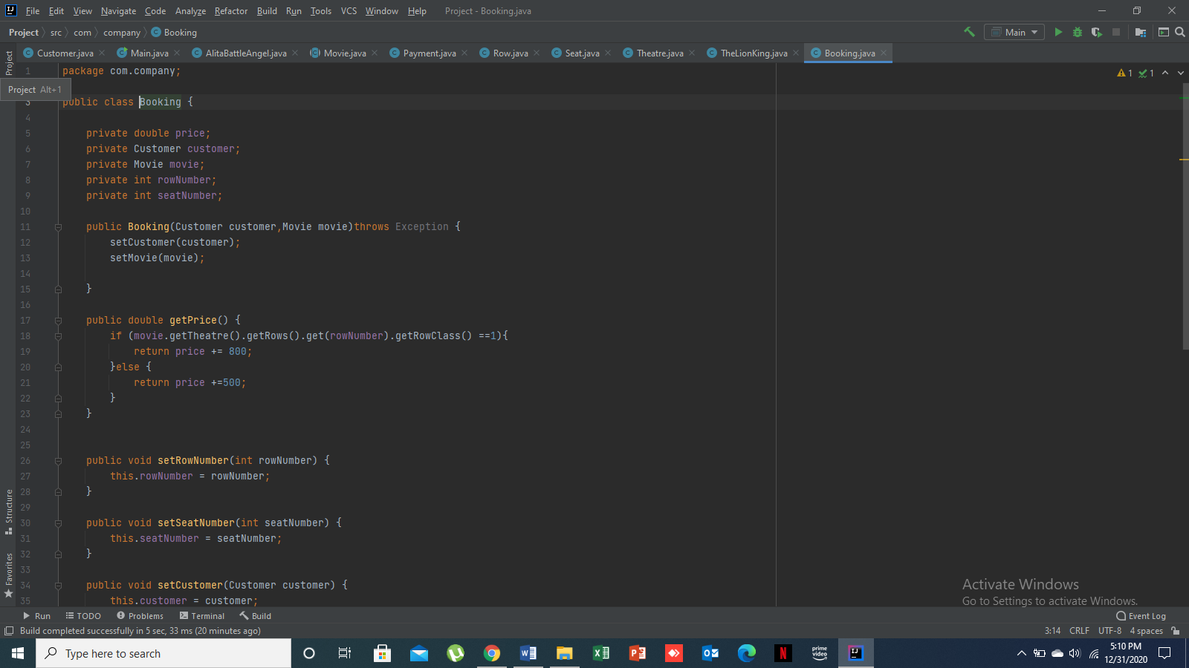

**Customer Class:**

